FOUNDATION FOR VIRTUAL AND AUGMENTED REALITY SYSTEMS
Lecture47
Lec-47: System Implementation
Hello and welcome to the NPTEL MOOCs course on Foundation for Virtual and Augmented Reality Systems. We are going to continue our discussion on system implementation. Now, as is customary, we will quickly recap what we have covered earlier and what we are going to do next; we will briefly talk about. So, previously under the system implementation topic, what have we learned? We learned about implementation ideas and
we learned about the implementation part of the overall design idea, that is the prototype and quick evaluation of the prototype and these two stages of the design prototype evaluation cycle. As we have mentioned. Although implementation involves actual coding and implementation, that part we have skipped because that is standard for any software development and there is nothing special to discuss. So, any existing material you can refer to for knowledge on code design and code implementation. We focused our attention on empirical evaluation, that is the usability evaluation of the end product.
That is done after the system is implemented. Earlier, quick evaluation was done after the prototype is implemented but not the full system, whereas empirical evaluation requires a full-fledged system which will be evaluated with the end user. So, we have gone through different stages of the empirical evaluation study process including the research question formulation, then identification of variables, Experiment design and finally data analysis and conclusion. So, that was all the theory that we have learned.
Let us try to understand this in the context of our case study so that we can relate the theory to practice. So, in this lecture what we are going to do is we are going to talk about the evaluation of the Majuli VR tour that we have taken as a case study. Just to recollect, this is a virtual tour of the Majuli river island. Our objective is to capture tangible and intangible ecological and cultural heritage aspects of the island. And we want to digitally preserve this heritage information by providing the users an immersive experience.
Why? Because the island is disappearing, and before it completely disappears, we want to digitally preserve the heritage information. Earlier we talked about different aspects of the system, including how we collected requirements, how we came up with the design, and how we have implemented the system. Now, we are going to talk about how we evaluated the implemented system. So, let us focus on the evaluation of the Majuli VR Tour.
Now the goal of the evaluation study of the VR tour is to measure various aspects of user engagement, presence, and comfort within the virtual environment. So, these are our objectives. Also, along with the measurement, we want to identify potential areas for improvement in the virtual tour by analyzing the participants' responses and symptoms of cyber sickness. So while measuring, we collect such responses either subjectively or objectively or both.
Now, based on this analysis, we want to identify the potential areas of concern where we can improve, and that is another goal: to identify areas of improvement. So, one is to measure certain aspects of the system from the usability point of view, and the other is to identify scopes for improvement. So, to evaluate as we have already talked about earlier in the empirical study discussion. Empirical study is nothing but collecting data from end users by the means of a controlled experiment where we make use of questionnaires for collection of data.
Now, the questionnaire is of course related to the research question; the use of questionnaire and it may lead to measurement of objective data, behavioral data or sometimes we may collect it through a rating scale. Now, here what we did is we used structured questionnaire and also we conducted controlled experiment to collect data to evaluate the Majuli tour. So, let us first talk about experimental setup, what setup we have used to carry out the experiment. So in our experiment in the empirical evaluation study of the Majuli VR tour, we made use of 27 volunteers.
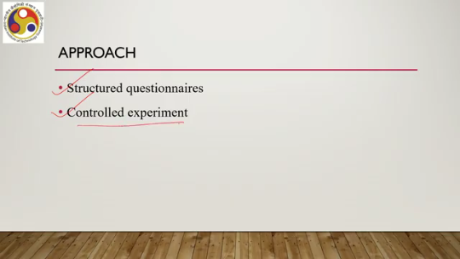
Among them 17 were male, 10 were female. They were divided into three user groups corresponding to the three categories supported by the system that is pilgrims, students and tourists. Nine in each group. So while While collecting the users and arranging the volunteers for participation in the experiment, we ensured that these participants had the characteristics of these three user categories: pilgrims,
tourists and students, and correspondingly we have divided them into three such groups so that for each group we can carry out the evaluation. The age range of the participants was between 23 to 40 years of age with a mean of 25.1 and standard deviation of 3.03. Among the 27 participants, 21 had prior VR experience. This information is important because this prior experience may bias the output. All of them were familiar with the joystick-based controller.
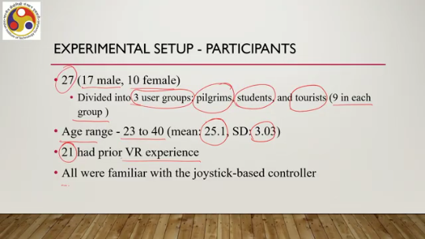
So, this type of controller they have used, whether in a VR context or non-VR context, they have used. So, they were familiar with the controller-based interaction mechanism and all had normal or corrected-to-normal vision. That was about the participants. What apparatus or setup did we use? We developed the system for MetaQuest 2, as mentioned earlier, with a resolution of 1920 by 1832 per eye.
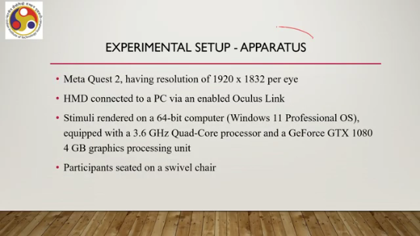
The HMD was connected to a PC via an enabled Oculus Link; that is the standard setup. The stimuli were rendered on a 64-bit computer with Windows 11 Professional OS, equipped with a 3.6 GHz quad-core processor and GeForce GTX 1080 4GB graphics processing unit, GPU. The participants were seated on a swivel chair. So while performing the tasks, they were sitting on a chair.
Remember that we developed the system in such a way that users can interact using controllers. So while the experiment was going on, participants were sitting on a chair. Then, in order to measure usability aspects, we have used standard questionnaires for the measure of presence, that is the psychological state of mind. We used the QEP questionnaire.
It was a revision that came out in 2004 of the presence questionnaire or PQ. The presence questionnaire is a standard questionnaire to measure presence. You can find out more about it yourself. And we have used a revised version of this presence questionnaire proposed in 2004 that is called the QEP questionnaire. It included 19 core items; it includes 19 core items and 3 optional items related to sound.
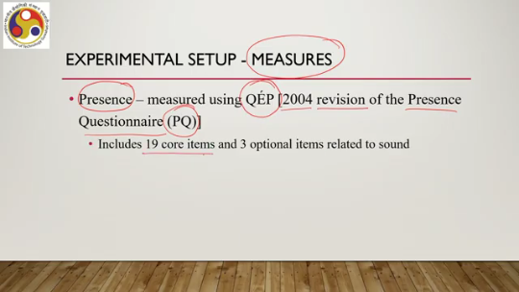
Now, the responses of the participants were recorded on a Likert scale ranging from 1 to 7. Now, this questionnaire also we have tailored for the Majuli VR Tour Assessment. In order to do so, we made use of two subjective items. If the user previously visited the island in person and, if so, whether the virtual tour corresponded with the experience gained during the real visit. For cyber sickness, what we did is we made use of another set of
standard questionnaires, a set of standard questions that is the simulator sickness questionnaire or SSQ. Interested learners may refer to our earlier discussion on cyber sickness where we mentioned this questionnaire. It is a very standard questionnaire although it was originally not developed for cyber sickness but for VR cyber sickness but It is very popular in measuring cyber sickness in the context of immersive experiences. Now the participants rated their symptoms on a scale from 0 to 3.
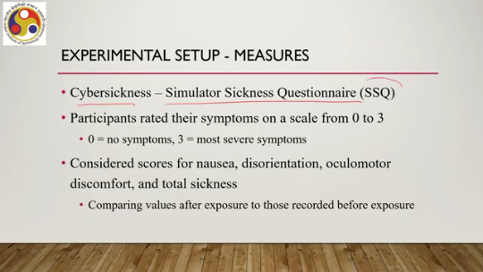
In the case of the previous presence questionnaire QEP, the rating scale used was between 1 to 7, a Likert scale. Here it is between 0 to 3. 0 essentially refers to no symptoms and 3 refers to the most severe symptoms. Now we have considered scores for nausea, disorientation, oculomotor discomfort and total sickness from this questionnaire. When we say we considered scores, essentially that means we computed the values,
After exposure and before exposure and then we compared them together to get an idea of the effect of the design on these values. So, let us talk about the procedure. So, we have explained the participants' experimental setup including the hardware used and the questionnaire used and then what procedure we followed. Now, the participants individually attended the sessions in a controlled setting.
They received training beforehand to ensure familiarity training on how to use the system before and a brief training session was organized for the participants. Where different ways, aspects of the system, different features, how to use those, all these things were demonstrated to them so that they become familiar. Otherwise, the issue is that those who are not familiar with VR systems may produce results much different from those who are familiar with VR systems. In that case, this familiarity bias may come in the output, which may lead to incorrect conclusions. based on the analysis of the obtained data.
So, it was necessary to bring all the participants to the same level so that this bias effect can be reduced or nullified. To do so, we conducted brief experiments, brief training sessions before the experiments began for all participants to become familiar with the system. Since we compared the cybersickness prevalence before and after using the system, before the participants were asked to carry out tasks in the system, they were asked to complete the SSQ as well. So SSQ before the experiment they had to complete so that we can compare the data after experiment. with the data after the experiment.
Now, this SSQ before experiment, as we have already talked about, served as pre-exposure assessment exposure to the system. So, pre-exposure assessment means before the user is exposed to the system. Next, we asked each participant to explore the entire tour on their own within a time span of 40 to 50 minutes. Now why this particular time span?
Why not say 10 minutes or why not say 1 hour? Why 45 to 50 minutes? Now through trials we have seen, through pilot studies, trials and some literature, we have seen that Since the island is large, we need to give the user sufficient time to explore different aspects and obtain the heritage information. If we give them less time, the entire island may not be explored.
If we give them more time, cyber sickness may happen because cyber sickness depends on exposure. So, we have to come to a point where the users get sufficient time to explore but the possibility of cyber sickness is minimized. Now through prior studies and trials we have estimated that time to be between 45 to 50 minutes and accordingly we gave the users time in that range so that they could explore the island whereas while
experiencing less cyber sickness. So, this estimation was done through other pilot studies and trials with different sets of people. At the end of the session, the experimental session, the participants were asked to fill out SSQ again, which is a post-exposure measure for cyber sickness. And they were also asked to fill out the presence questionnaire, that is the QEP questionnaire. So just to recap, everybody had to explore the island individually.
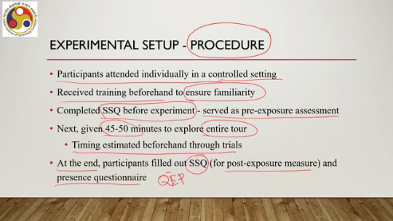
All of them were exposed to a training session beforehand so that all are at the same level while starting the exploration. Then we estimated the sufficient time to be given to explore the whole island without exposing the user to cyber sickness risks is between 45 to 50 minutes and that much time was given to each participant. So participants before starting the exploration had to fill out SSQ questionnaire and after the exploration is done they had to fill out both SSQ and QEP questionnaire. So this is how standard controlled experiments are carried out.
First, you have to define the users and identify the participants carefully. Then the setup you have to take care of that includes the hardware software setup as well as additional setup like questionnaires and support for experimentations, additional logistical support and so on. Thirdly, you have to define a procedure which eliminates possibilities of biases. For example, here by arranging a training session, we eliminated the possibility of prior experience bias.
So all these stages are important in any controlled experiment. Now we have carried out the experiments. Let us have a look at the results. So first let us have a look at the results on presence, the measure of presence. Now the measure contains several items, say involvement, interface quality, adaptation or immersion and visual fidelity.
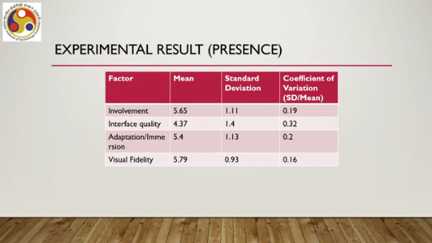
So, the mean we obtained based on the ratings provided by the users for involvement is 5.65, interface quality 4.37, adaptation and immersion 5.4, visual fidelity 5.79 with a standard deviation for say involvement is 1.11 and coefficient of variation 0.19, interface quality SD is 1.4, coefficient of variation 0.32, adaptation standard deviation 1.13, coefficient of variation 0.2, visual fidelity adaptation, visual fidelity standard deviation 0.93, coefficient of variation 0.16. So, what do these numbers indicate?
We will come to that. Now, there are some more items. So the previous one was the overall thing. Now we separately collected scores for the users who had already visited Majuli Island; users here means participants who had already visited Majuli Island. We have separated out that information.
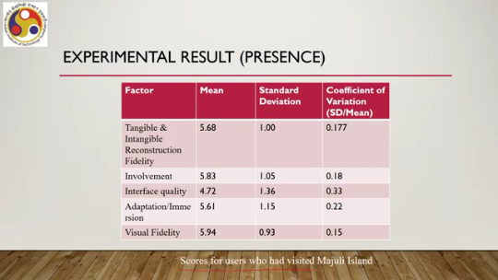
Now in the tangible and intangible reconstruction fidelity item, The mean found was 5.68, standard deviation 1, and coefficient of variation 0.177. Involvement mean 5.83, SD 1.05, and coefficient of variation 0.18. Interface quality mean 4.72, SD 1.36, coefficient of variation 0.33; adaptation immersion 5.61 mean, standard deviation 1.15, coefficient of variation 0.22.
Visual fidelity mean 5.94, standard deviation 0.93, and coefficient of variation 0.15. Again, these are some numbers that we have obtained. Now, these numbers we can summarize simply as overall good presence. So, all these items point to the fact that with the system, the users felt good presence.
That means they were reasonably well located within the virtual environment while exploring the island virtually. Also, the data revealed that users who had visited the island before tended to provide more favorable opinions compared to the overall opinion for all factors. So, it is quite obvious that those who had visited the island have some experience. So, now the critical factor here is that those who had visited the island have more expectations compared to those who had not visited the island.
So, if the system does not meet those expectations, then certainly their score should be low. However, the opposite happened here. That means those who had visited the island felt more comfortable with the system, with the digital exploration of the island. That means the system has been able to reasonably well mimic the physical environment of the island with its design elements, with its interaction and overall implementation.
So, that is a good sign that the digital avatar is close to reality, as attested by the results obtained from those who had visited the island. Also, we found a significant difference between experienced and inexperienced users. Those who had exposure to digital tours, virtual tours and those who do not have. And this was revealed through statistical significance testing where we used the Welch t-test. This is one of the tests that we had mentioned in the previous part of the lecture.
You can refer back to that. So several interesting facts, overall good presence, the system could manage to convince those who had visited the island that this is closer to reality, and prior exposure to such systems always helps gain a better experience. Now let us come to the other result, that is cyber sickness. We use the SSQ
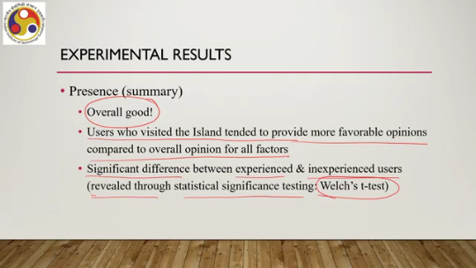
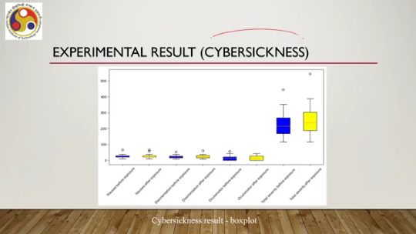
Questionnaire to measure it and there we collected data for pre and post exposure situations. So, let us see the different results that were obtained. Nausea before exposure shown in this box plot, nausea after exposure shown in this box plot. Similarly, disorientation before exposure and disorientation after exposure are shown in these two box plots. Oculomotor before exposure and oculomotor effects after exposure shown in these two, whereas total severity before exposure and total severity after exposure are shown in these two box plots.
As you can see, mostly there is not much difference before and after exposure. That indicates that the system is not inducing cyber sickness to the users. These are of course average numbers. However, there is a difference in total severity before and after, whereas some difference in oculomotor severity before and after. So in summary what we can say is that there is not much significant difference in pre and post scores except for oculomotor and total sickness as we can see from the box plot.
Now this difference we can see the difference but whether that is statistically significant or not we have to test as we discussed earlier. Now here we performed a statistical significance test that is the Wilcoxon signed rank test. And that reveals that there is significant difference between pre and post exposure situations, outcomes with respect to the oculomotor item and the total sickness item. So, indicating that total sickness, there is some effect of the design. However, individually nausea or
Disorientation is not affecting much; however, oculomotor there may be some issue because of controller usage eye movement there may be some issue which may be leading to total severity getting changed before and after usage of the system from total severity getting changed after the system is used, so that is about evaluation of the Majuli virtual tour overall the result is good with some areas of concern. So, remember that we started by telling that the goal of the evaluation is twofold one is measuring other one is identifying potential areas for improvement. So, we have measured presence we found mostly good results however, we found that
prior experience may lead to even better results. So, probably people with prior experience may find it more acceptable as compared to those without experience. Secondly, on cyber sickness, we found that certain items are not affecting the severity. However, oculomotor may get affected. which may lead to some effect on total sickness.
So, there something may need to be done. So, in summary, we learned about this cycle empirical evaluation and evaluation illustrated through the case study of Majuli VR Tour. In fact, here we have also learned how to conduct an experiment, how to describe the experiment, We have to talk about participants in detail, their profiles. We have to talk about the setup.
We have to talk about the procedure. We have to obtain and process the data, and visually represent them in terms of some plots. And then from there, we can draw some inferences and conclusions. In the next part of the lecture, we are going to briefly talk about the practical implementation of interactive system development life cycles, which is the agile development idea.
So with that, we have come to the conclusion of this part. I hope you could follow the idea of evaluation. You could relate the theory with practice, the practical setting, how the evaluation is carried out and described. Description is also important. So looking forward to meeting you all again in the next lecture.
the next part of the lecture. Till then, thank you, goodbye, and happy learning.

